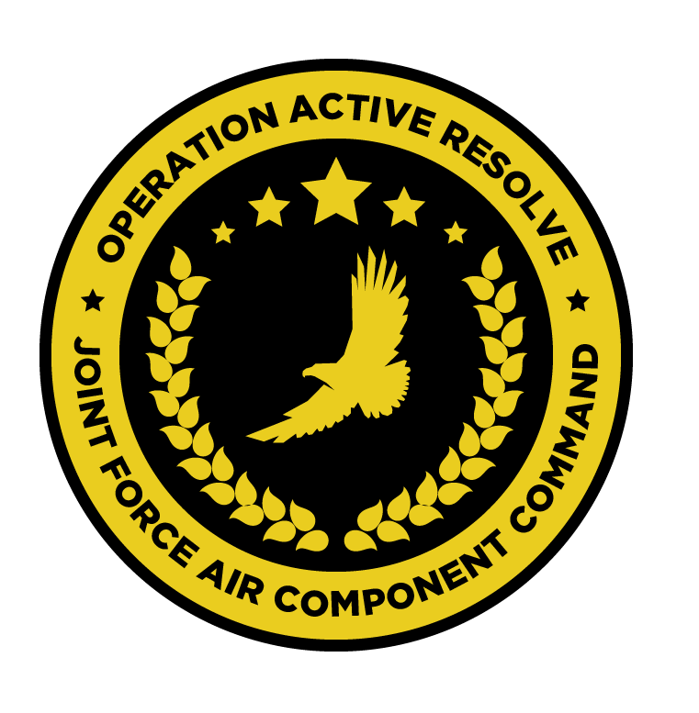

JFACC INSTRUCTIONS

# INTENTION

Aim of this document is to give a understanding of the JFACC role, responsibility, tasks, inputs and output to aid volunteers filling a JFACC role under 132nd campaigns.

# JFACC ROLE DESCRIPTION

JFACC is the commander of the Joint Air Forces in the operation.

# TASKS

* Allocate sorties (by percent) to the following:
  + DCA
  + OCA
  + AI
  + CAS
  + Strike
* Assign priorities to regions/sectors for the coming ATO period
* In collabaration with VIS, publish JPTL for the coming ATO period (targets that are to be attacked
* Responsible for the AI campaign to defeat the enemy
* Give additional guidance and priorities as needed
* Provide guidance for risk level for AWACS and tankers (operating further back or forward)
* Can give directions for placement of Patriot Air Defence battalions

# INPUTS

* VIS INTSUM (Intelligence summary)
* VIS INTREP + other INTREPs (Intelligence reports)
* CJTF OPORDER
* Media
* Air Operations Plan (campaign plan) (Can also be adjusted by JFACC)

# OUTPUTS

* Air Operations Directive (including where Patriot Air Defence batt should be located)
* JPTL (attachement to AOD)
* TST matrix (attachement to AOD)
* Injects to SPINS (Normally not needed).